Project Infrastructure Handover by German Team
References:
www.youtube.com/@berndruecker6433
Topics:
- AWS
- OpenShift
- Camunda
- Keycloak
- Helm

- AWS:
Topic Name: Services
Question | Answer
What are all aws services used for infrastructure? | AWS is used only for the RDS database postgres for the keycloak and webmodeler database.
How is the interaction/ interface between OpenShift and AWS looking like? | It is connected via AWS Transitgateway. We don’t must do anything
How is the data storage looking like? Which (AWS-)services are used for which data? | 1x RDS Postgres database and 2 schemas for webmodeler and keycloak respectively.
What are the important Kubernetes components for Camunda application? | There is no kubernetes in AWS, or did i undertood the question wrong?

- OpenShift:
Topic Name: OpenShift
How is network routing handled (Ingress, Routes, or LoadBalancer services)? | Ingress is handled by routes, which route the traffic to the service (with pods as endpoint). Routes are defined on OpenShift and corresponding subdomains can be defined in the processengine.cloud.audi hosted zone on AWS.
What is the process to deploy an application in OpenShift using Helm? | The process to deploy the application on OpenShift is explained on Audi Confluence: Installation/ Upgrade Camunda - ProcessEngineAudi - DevStack Confluence
What kind of resources do we typically deploy? (Deployments, StatefulSets, Routes, etc.) | The Resources deployed are listed on Audi Confluence: Application Setup on OpenShift - ProcessEngineAudi - DevStack Confluence
Do we use Operators or custom OpenShift resources? | all resources (except the secrets, see below) are handled within the values.yaml of the helm-chart. No special Operators are in use.
How are secrets and environment variables handled in OpenShift? | Defining of the secret.yaml is explained in the readme.md of the Bitbucket Repo. Secrets currently used are listed here: Camunda Secrets - ProcessEngineAudi - DevStack Confluence
Are there security policies or network policies we must be aware of (e.g., SCCs, PSPs)? | networkpolicies allow all ingress/egress between pods of a namespace. SCCs are OpenShift default restricted-v2 and defined in values.yaml of the helm-chart.
How do we monitor deployed applications (logs, metrics, alerts)? | monitoring of services needs to be done within the pods. After migration, there is supposed to be the possibility of an integrated monitoring. Performance Monitoring can be done via OpenShift Console or via Console-Service of Camunda.

What is a Project in OpenShift?

- A Project in OpenShift = a Namespace in Kubernetes.
- It logically isolates resources like:
- Pods
- Services
- Deployments
- Secrets
- ConfigMaps
- Routes
- Think of it as a “folder” or “workspace” for a team, microservice, or environment (like dev, QA, prod).

Example Output:

You have access to the following projects:

*bankruptcy-qa

bankruptcy-dev

bankruptcy-prod

openshift

default

The * indicates the current active project.

Related Commands:
Command | Description
oc project <name> | Switch to that project (make it current)
oc new-project my-app | Create a new project
oc delete project my-app | Delete a project (if you have permissions)

# List all accessible projects

oc projects

# Switch to the project 'bankruptcy-qa'

oc project bankruptcy-qa

After switching, all future oc commands like oc apply, oc get pods, etc., will run inside that project.

"oc" stands for: OpenShift Client

What is oc?
- oc is the command-line tool for interacting with OpenShift clusters.
- It is the CLI equivalent of kubectl (Kubernetes CLI), but with OpenShift-specific extensions.

Key roles of oc
Area | What oc helps you do
Navigation | Switch between projects (namespaces), list resources
Deployment | Create or apply YAML files to deploy applications
Inspection | View logs, pods, services, routes
Security | Manage service accounts, roles, secrets
Debugging | Get into pods, check events, describe resources

Example Commands:

- oc login https://<openshift-cluster-url> --token=<your-token> # Login to OpenShift
- oc new-project demo-app # Create a new project
- oc get pods # List pods in current project
- oc apply -f deployment.yaml # Apply configuration
- oc logs <pod-name> # Check logs
- oc exec -it <pod-name> -- bash # Get shell into a pod

For installation OC (OpenShift Client) We can go to this location

https://console.redhat.com/openshift/downloads

OpenShift Client commands:
- oc get svc - List services in your project
- oc project <env name which we want to switch> ex: oc project camunda-dev
- oc projects – Using this command we can see currently which environment we are.
- oc get pods – We can see all the pods status
- oc get pods -n camunda-prelive – we can see the pods in specific environments
- oc get pods -n camunda-prelive -o wide – We can get the information about IP of support and which node that part is scheduled. Maybe in some more info when we want to check connection from one port to another this could be helpful.
- oc get deployments – Get the deployments and get the number of parts which are ready.

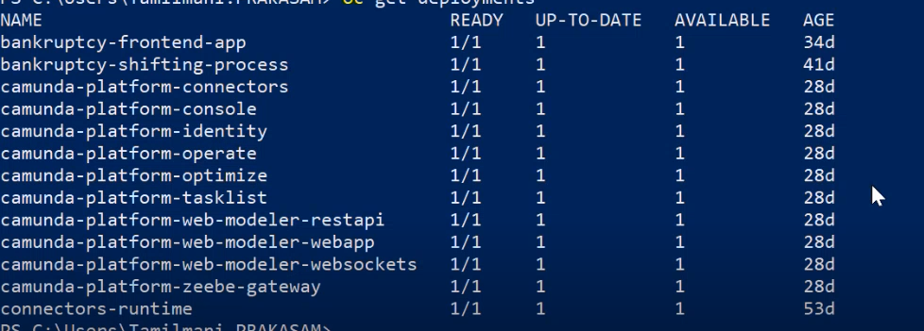

If three zeebe running, then we will have 3/3 ready.
- Zeebe is a stateful set oc get stateful set

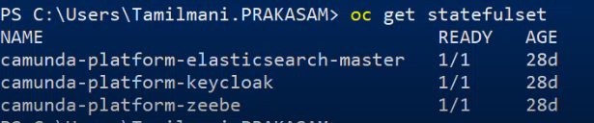

Because of communication between these pods and make them clearly named with that index at the end

So, this is just one detail about that, but its in the end this is not important for deployment, reason is why this is stateful set this is the reason.

- Camunda:
Question | Answer
What is the backup and restore process for Camunda data and workflows?  Important link to understand Camunda 8  https://github.com/camunda/camunda | Keycloak and webmodeler has their backup automatically via its RDS functionality.  For the databases of Zeebee or elastic we dont have currently backup n restore processes.

Keycloak: Recording session – 1(IAM)
Auth process:
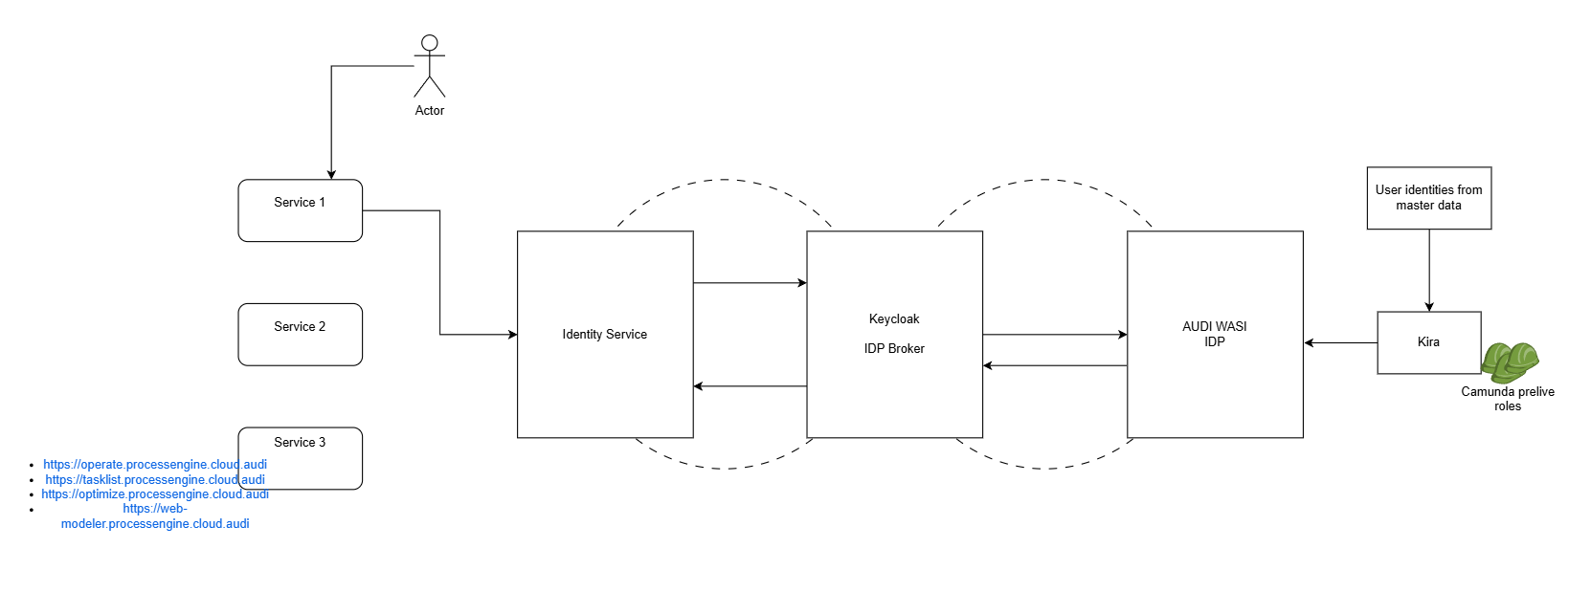
The whole IAM solution for this Camunda for this Audi project is basically consist of different tools. Tools from Audi side and Akkodis side.
This is the process for the Single sign on (SSO)
Actor or user who wants to basically the access for one service for example web modeler service.
How the process flows whenever he tries to access the service 1 -> This service is basically secured with identity service form the Camunda and identity service in the backend relates to the Keycloak. Keycloak IDP broker is basically identity provider. Audi WASI IDP it is also another identity provider from the Audi side.
Audi WASI IDP (Identity provider) – This is mainly providing the SSO capabilities for Audi’s applications. It is just like custom identity provider they have integrated into our Keycloak for the environment like dev, prelive, and prod. This is only SSO purpose.
Keycloak IDP broker – This is basically using as a broker + some of the capabilities we are managing here. So, we are not completely relying on Audi WASI IDP.
Kira – It is basically the privileges access from the Audi side, user identify from master data and Audi decide which user can access which service.
User wants to access one of the services, the service redirects the user into the identity service for the login page there we can see option of login via Audi SSO and via Keycloak IDP broker this request is goes to Audi WASI IDP the user login there with the successful token and comeback to the Keycloak. It basically let’s the user into the service.
So how it works from the process perspective:
Whenever Audi wants to onboard particular user, and Audi wants to allocate to some permissions to that person
For the permissions and roles are basically allocated at the Kira side. We are not maintaining that in the Keycloak anywhere we gave the Audi. We do not have access that we can’t be able to be seen that it’s not relevant to look it’s the only thing we knows which user is having what set of permissions.
Identity service – We are not explicitly using managing identity service from the operational perspective. We are deployed because all these services are secured by identity service.
Mainly go with two directions
- Related to Single sign on login (SSO)
- How we are managing the role-based access control, how we have implemented in the Keycloak and how it works end to end as shown the above picture.
Step -1 - https://auth-prelive.processengine.cloud.audi/auth/admin/master/console/#/camunda-platform
Login Keycloak using this URL -> In the Keycloak there is a concept of realm roles Whenever we install the Keycloak at least have a sort of sets of configurations or organizations. We have Master and Camunda-platform.
So, anything related to the Keycloak itself from the administrative perspective we need go to the Keycloak master.
Here disabled the amin user from the best practice perspective. So, in any identity provider we should really keep disable admin access. So just for the purpose of audit trials.
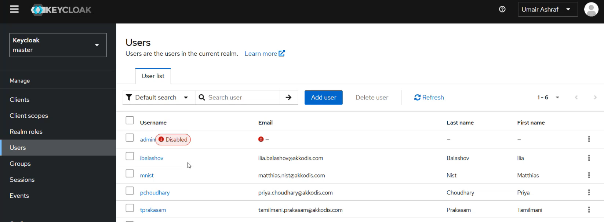
Here we can create the user to click on the Add user button. -> Then we can see the dropdown there we can select the configure OTP and update password -> Turn on the Email verified radio button -> add the user details here.
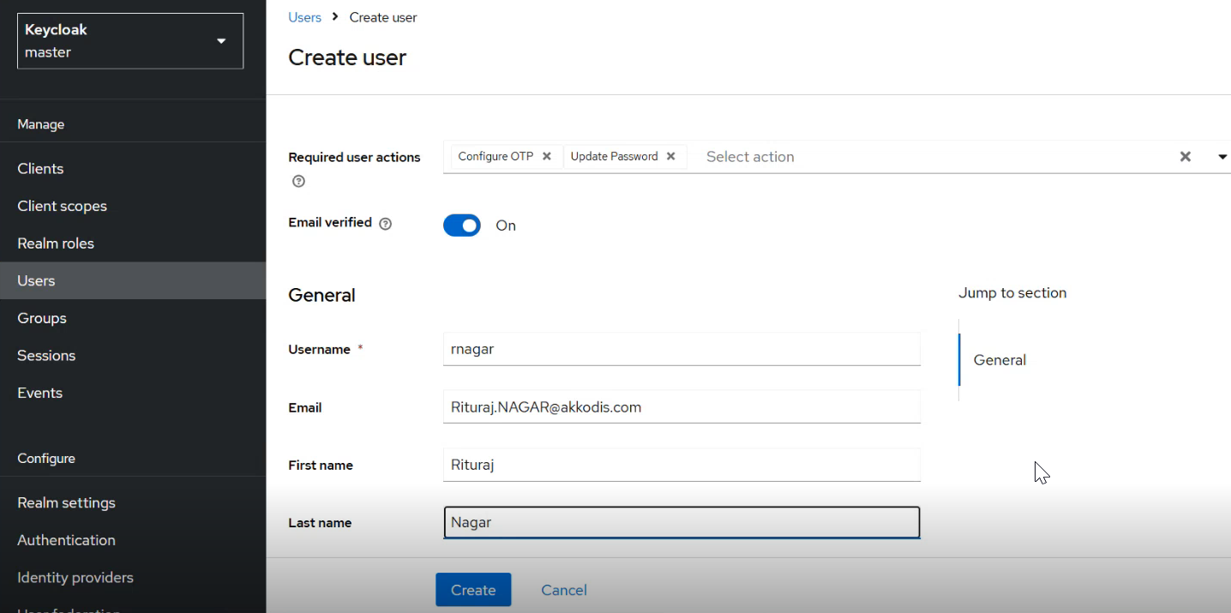
Click on the join group pop-up open select admin checkbox and join the group -> Click on the create so that afterwards have the access of this Keycloak. This is not integrated with any AMTP now -> then go to the credentials -> set the password. -> Groups tab doesn’t give the admin access any of the Audi people. Because we are doing operations in future, so we only have this role.
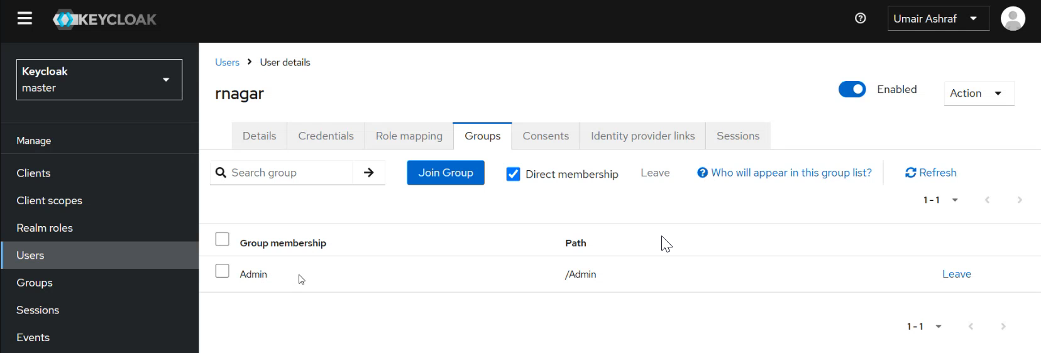
Camunda-platform
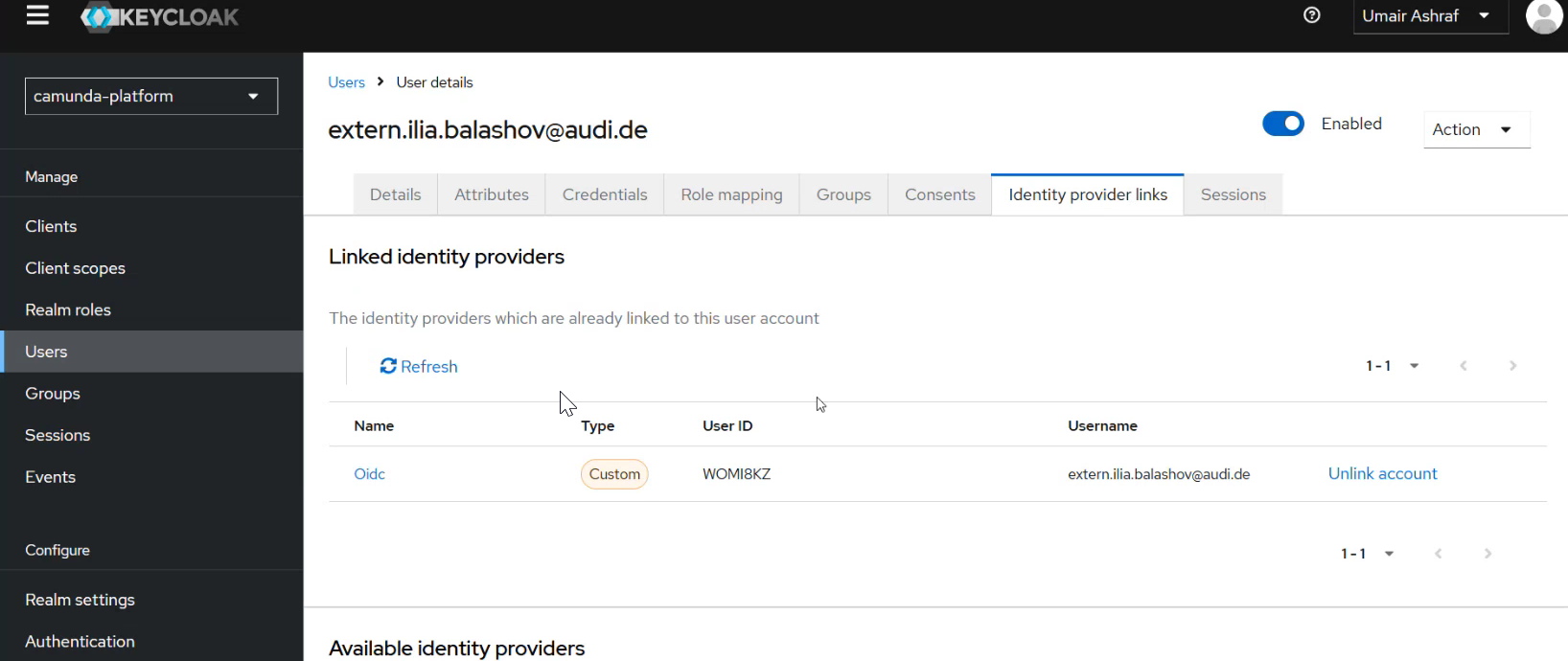
Don’t unlink this account
Identity Provider
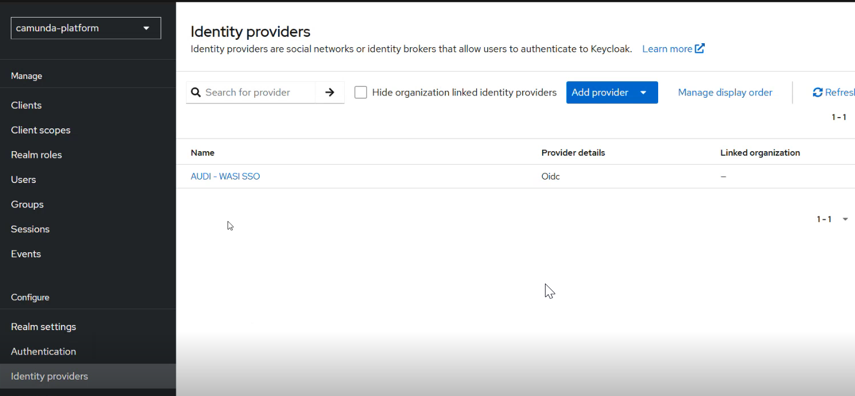
Audi com into the future and integration with for example LinkedIn and fill all the details and reflected same as
Audi – WASI SSO and under this there will be the configuration.
So
Camunda Components:
- Modeler
Camunda Modeler is a desktop application used to visually design and model BPMN (Business Process Model and Notation), DMN (Decision Model and Notation), and CMMN (Case Management Model and Notation) diagrams. It’s a key tool in the Camunda platform that helps you create workflows and decision logic that the Camunda engine can then execute.
Key Uses:
- BPMN Diagrams – For modeling business workflows.
- DMN Tables – For defining business rules.
- CMMN – For modeling case-based (less structured) processes.
Example: BPMN Workflow in Camunda Modeler
Let’s say you’re building a simple Leave Request Process.
- Start Event → A user submits a leave request.
- User Task → Manager reviews the request.
- Exclusive Gateway → Decision:
- If approved, move to approval confirmation.
- If rejected, notify employee.
- End Event
This can be drawn easily in Camunda Modeler with drag-and-drop elements and deployed directly to a Camunda engine.
Real-World Use Case:
A company automates its invoice approval process. The business analyst uses Camunda Modeler to design a BPMN workflow, including tasks like invoice upload, validation, and finance approval. Once the diagram is deployed, it runs in the Camunda engine and handles real tasks.
- Connectors
Connectors in Camunda are pre-built or custom components that allow your BPMN processes to interact with external systems or services without writing custom code in every instance. They simplify integration by allowing you to configure them directly in the Camunda Modeler.
What Do Connectors Do?
They help automate tasks like:
- Sending emails
- Making REST API calls
- Accessing databases or cloud services
- Connecting to internal tools (e.g., Jira, Slack, Salesforce)
Example: Using a REST Connector
Imagine a process step that needs to send data to an external API (e.g., submitting a form to a web server). Instead of writing custom Java code, you can use a REST Connector.
In Modeler:
- Add a Service Task in your BPMN diagram.
- Choose REST Connector as the implementation.
- Fill in details:
- URL: https://example.com/api/submit
- Method: POST
- Headers, payload, etc.
Camunda will handle this API call at runtime using the connector.
Real-World Use Case:
In an HR onboarding process:
- A REST Connector sends new employee data to a payroll system.
- An Email Connector sends a welcome email to the new hire.
- A Slack Connector notifies the IT team to set up their workstation.
All of this can be done with minimal code using connectors.
- Forms
Camunda Forms are used to create user interfaces (UIs) that are shown to users during User Tasks in a BPMN workflow. These forms collect input or display information when human interaction is needed in the process.
Camunda provides two types of forms:
- Embedded Forms (using HTML + JavaScript – legacy)
- Camunda Forms (new) – Low-code, form builder directly in Camunda Modeler
What Can You Do with Camunda Forms?
- Display data to a user
- Collect inputs like text, numbers, checkboxes, dates, etc.
- Dynamically show/hide fields based on logic
- Validate inputs before submission
Example: Leave Request Approval Form
In a process where a manager needs to approve leave:
- A User Task is created: "Approve Leave"
- Attached to this task is a Camunda Form with:
- Employee Name (text field)
- Leave Dates (date range)
- Reason (text area)
- Decision (dropdown: Approve / Reject)
- Comments (optional)
When the manager logs into Camunda Tasklist, this form appears. After submitting it, the process continues
based on their selection.
Real-World Use Case
In a customer onboarding process:
- A Sales Rep gets a User Task with a Camunda Form.
- The form includes customer details pulled from the previous system step.
- The rep can edit details or approve the onboarding directly through the form.

- Camunda Workflow Engine
The Workflow Engine is the core part of Camunda. It executes BPMN processes, managing their flow step by step.
What It Does:
- Runs your process models (BPMN)
- Manages tasks (user tasks, service tasks, gateways, etc.)
- Keeps track of process state
- Assigns tasks to users or systems
- Controls how the process moves from start to finish
Example: Leave Request Process
You design a process with:
- Start Event
- User Task (Manager reviews request)
- Exclusive Gateway (Approve or Reject)
- End Event
The Workflow Engine runs this process:
- Triggers the start event
- Creates a user task for the manager
- Waits for input
- Follows the decision path
- Ends the process
You don’t need to write logic — the engine follows the BPMN flow.
- Camunda Decision Engine
The Decision Engine executes DMN (Decision Model and Notation) tables. These are rule-based logic models used to separate complex decision-making from process flows.
What It Does:
- Evaluates decision tables
- Applies business rules
- Outputs results based on given inputs
Example: Loan Approval Rules
You create a DMN table with rules like:
Credit Score | Income | Loan Amount | Approve?
> 750 | >50K | <100K | Yes
< 750 | <30K | >50K | No
The Decision Engine evaluates this table when called in the BPMN process and returns the result (Approve = Yes or No), which then guides the next step in the process.
How They Work Together:
- The Workflow Engine runs the overall process.
- It calls the Decision Engine when a decision task (DMN) is encountered.
- The decision result then determines the process path.

- Tasklist
Tasklist is the user interface where human users interact with workflow tasks assigned to them. It’s part of the Camunda platform and is used to complete User Tasks that require human input in a process.
What It Does:
- Shows a list of tasks assigned to you or your group
- Allows you to open a task, view its form, and complete it
- Displays task details like:
- Task name
- Assignee
- Process name
- Due date
- Automatically updates as tasks are created and completed
Example: Leave Approval Process
In your BPMN model:
- A User Task is assigned to the "Managers" group.
When a process instance reaches that step:
- A manager log into Tasklist
- Sees a new task: “Review Leave Request”
- Opens it, fills out the form (approve/reject), and submits
- The process continues based on their decision
Real-World Use Case
In an invoice approval workflow:
- Finance team members get assigned tasks via Tasklist
- Each task includes a form to review invoice details
- Once approved, the workflow continues to payment processing
Tasklist Users
- Business users
- Managers
- Anyone assigned to User Tasks in a process

- Operate
Camunda Operate is a monitoring and troubleshooting tool used to track and manage running and completed process instances in Camunda 8 (note: not part of Camunda 7). It helps developers and operations teams see what’s happening inside workflows in real time.
What You Can Do in Operate:
- View active and completed process instances
- Drill into process paths to see which steps are completed, active, or failed
- Retry failed tasks or fix issues
- Monitor incident details (e.g., why a service task failed)
- Search and filter by process name, ID, variables, etc.
Example: Order Processing Workflow
Let’s say you have a process where:
- Order is placed
- Payment is processed
- Inventory is updated
- Confirmation email is sent
If the payment API fails, Operate shows:
- The process is stuck at "Process Payment"
- The exact error (e.g., HTTP 500)
- You can retry the step or cancel the process
Real-World Use Case
In a logistics company:
- A shipment workflow involves external APIs for carriers
- Sometimes, API calls fail or timeout
- The operations team uses Operate to detect failures fast and retry them — without restarting the whole process

- Optimize
Camunda Optimize is an analytics and reporting tool that helps you gain insights into your process performance. It’s mainly used by business analysts, process owners, and managers to monitor KPIs, identify bottlenecks, and support continuous process improvement.
It’s available in Camunda 8 and as an enterprise feature in Camunda 7.
What You Can Do in Optimize:
- Create dashboards and reports for process and decision data
- Track process performance metrics (e.g., average completion time, task duration)
- Identify bottlenecks and delays
- Analyze decision outcomes from DMN
- Filter by variables, user, date range, and more
Example: Invoice Approval Process
You can create a dashboard that shows:
- Total number of invoices processed this month
- Average approval time per user/task
- Number of rejected invoices
- Instances where processing time exceeded SLA
This helps you identify inefficiencies, like a user taking too long to approve, or a specific task causing delays.
Real-World Use Case
In a customer onboarding process, management uses Optimize to:
- See how long it takes from application to approval
- Identify which departments are slowing down approvals
- Track rejections by reason
- Make data-backed improvements to the process
Component | Purpose
Console | Central admin interface for managing Camunda
Modeler | Design workflows and decisions
Engine | Executes the workflows and rules
Tasklist | Handles user tasks
Operate | Monitors and debugs process instances
Optimize | Analyzes performance and generates insights

- Identity
Camunda Identity is the user and access management component of Camunda 8. It handles authentication (who can log in) and authorization (what they can do) across all the Camunda web applications like Tasklist, Operate, Optimize, and Console.
What You Can Do with Camunda Identity:
- Create and manage users (usernames, passwords, roles)
- Assign roles and permissions (e.g., access to Tasklist, deployment rights)
- Integrate with identity providers (LDAP, OAuth, SSO, etc.)
- Manage groups, tenants, and scopes for multi-tenant systems
Example: Role-Based Access
Let’s say you have:
- A Business Analyst: needs access to Modeler, Optimize
- A Developer: needs access to Modeler, Console, Operate
- An HR Manager: should only see Tasklist
You configure these roles and access levels in Camunda Identity, so each user only sees the apps and data relevant to them.
Real-World Use Case
A company using Camunda across multiple teams:
- Integrates Camunda Identity with their corporate SSO (e.g., Okta, Azure AD)
- Sets up custom roles like Process Designer, Operations, Viewer
- Ensures secure access by controlling who can deploy models, view incidents, or complete tasks
Why It Matters
Identity ensures:
- Security: Only authorized users can access sensitive workflows.
- Separation of concerns: Developers, managers, and business users have tailored access.
- Compliance: Aligns with enterprise policies and audit requirements.

- Console
The Camunda Console is the central web interface in Camunda 8 where you can manage and configure the entire Camunda platform. It acts as the administrative hub for your environment.
What You Can Do in Camunda Console:
- Manage clusters, tenants, and users
- Deploy BPMN or DMN models
- Monitor resource usage
- Access other tools like Modeler, Tasklist, Operate, and Optimize
- Configure authentication, permissions, and environments
- View logs and system health (in some enterprise setups)
Example Use Case:
Suppose you're setting up a new project team in Camunda 8:
- You go to the Console.
- Create a new tenant for that team.
- Assign users and roles.
- Deploy their BPMN and DMN models.
- From the Console, link them to their own Tasklist and Operate views.
This way, you manage everything securely and neatly from a single place.
Real-World Use Case
An organization using Camunda for multiple departments uses the Console to:
- Set up separate tenants (HR, Finance, IT)
- Manage access control for each department
- Deploy and manage models independently
- Monitor health and activity from one dashboard

- Web Modeler
Camunda Web Modeler is a web-based tool that allows you to design and model BPMN (Business Process Model and Notation), DMN (Decision Model and Notation), and CMMN (Case Management Model and Notation) diagrams directly in a browser. It’s part of the Camunda 8 ecosystem and provides an easy way to create workflows, decisions, and case models without needing to install software locally.
Key Features:
- No installation required: Use it directly from your browser.
- Support for BPMN, DMN, and CMMN: You can design complete workflows, decision logic, and case management models.
- Intuitive drag-and-drop interface: Build models visually with minimal effort.
- Real-time collaboration: Share models and collaborate with other users.
- Direct deployment: Once the model is ready, it can be deployed to the Camunda engine for execution.
Example: Building a Leave Request Workflow in Web Modeler
- Create a BPMN Process:
- Start with a Start Event (triggered when an employee submits a leave request).
- Add a User Task for the Manager to review the leave request.
- Add an Exclusive Gateway to decide:
- If approved, go to "Confirm Leave."
- If rejected, notify the employee.
- Add End Events for both paths.
- Deploy the Model:
  - Once the diagram is ready, click the "Deploy" button to push the workflow to the Camunda engine.
Real-World Use Case
Imagine a customer service request process. The Web Modeler lets a business analyst design the flow:
- Request received → Assign to appropriate team member → Customer updates → Close request.
- The model is shared and reviewed by the team, and once finalized, it’s deployed and executed in the Camunda engine.

Topic – Helm and OpenShift:
- Kubernetes: https://kubernetes.io/
It is an open-source container orchestration platform that automates the deployment, scaling, and management of containerized applications. It was originally developed by google and now is maintained by the cloud native computing foundation (CNCF). One more advantage of the Kubernetes is it is cloud neutral.
Capable of the Kubernetes:
- Service discovery and load balancing
- Container and storage orchestration
- Automated rollout and rollbacks
- Self-healing
- Secret and configuration management.
So, with the help of Kubernetes, we can control any number of containers along with the storage requirements.
Why should we go with a complex setup of Kubernetes cluster? Can we deploy all our microservices with the help of docker compose alone?
- We cannot deploy all our microservices containers with the help of docker compose. Because whenever using our docker compose we are going to deploy all our containers inside a single server. But in a real production application we may have 100s of microservices we cannot deploy. Instead, we want to build an multi distributed environment where we can deploy our microservices in various servers are nodes inside the cluster.
- Docker compose is not capable of automatic deployment, rollouts, scaling. So, that’s why we need to use the Kubernetes container orchestration.
Kubernetes internal Architecture:
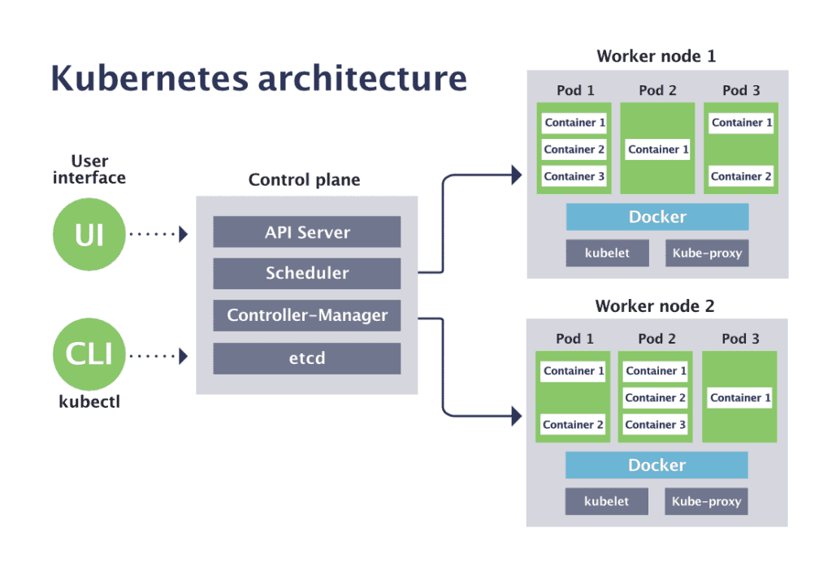
Kubernetes clusters will have 2 types of nodes one is master node which is responsible for controlling, maintaining entire Kubernetes cluster another one is worker node is responsible to handle the traffic that we get towards our microservices.
Components of the Master Node:
API Server – using this APIs Master and worker node both are communicating each other. API server based on the Admin UI and kubectl CLI instructions it understands, and it is going to give those to scheduler.
We have two approaches whenever we are interacting with the Kubernetes cluster one is using Admin UI and other option is kubectl CLI -> here execute some command this will input to the API server with the YAML configuration all the information we can provide this YAML configuration to the master node with the help of using these two commands.
Scheduler – what are the requirements it received form the API server based on identify under which worker node the deployment of our based on the Admin UI and kubectl CLI input service has be done. Behind that it will calculate which worker node have a bandwidth, which worker node busy by considering all these calculations it identifies one of the worker nodes presents inside the Kubernetes cluster.
Controller-manager – we can assume like one of my microservices is deployment is completed inside one of the worker nodes available. Maybe after few days and hours container may have some problem. So, controller-manager is going to track that, and it is the responsible to controller manager to always track the containers and worker nodes available inside the cluster. If any container has some health issue. It is bringing new worker node. Its main intension is regular keep health check.
etcd – it is a brain of our Kubernetes cluster. It is going to be act as a database or a storage system for our Kubernetes cluster. It stores all the information related to our Kubernetes is going to store as a key-value pair.
Components of the Worker node:
Kubelet – It is an agent running in all our worker nodes using this master node is going to connect with the master node and it gives the instructions with the help of API server. So, master node has given instructions to the worker node saying that deploy this microservices replica of 3 all such instruction received worker node going to the help of kubelet.
Docker (Container runtime) – The purpose of this since we are going to deploy all our microservices in the form of container we need to make sure there is some container runtimes install the worker node. All our worker nodes they are going to have the docker server inside them.
Pod – it is a smallest deployment unit inside the Kubernetes. Worker node is going to be a jumbo server or a virtual machine we cannot deploy our containers into the worker nodes. Instead, the Kubernetes is going to create a pods inside the worker node and inside this pod only actual containers of the microservices are going to be deployed.
The reason is supposed we are trying to deploy multiple microservices into the same worker node. To provide that isolation from other microservices we have a concept called pods. Most of the time pod will have a single container and specific microservices container will be allowed.
Some pods have multiple containers, the reason is sometimes the deploy multiple containers inside the pod is for some other containers needs some helper container, or utility container to perform its job. So, such container we can deploy inside the same pod where we have the main container. This is called side car pattern.
Kube-proxy – To expose our container to the outside world or to the other container into the same cluster Kubernetes is going to use a component called kube-proxy.
https://docs.docker.com/desktop/features/kubernetes/ - Documentation for Kubernetes practical cluster run.
Commands:
kubectl – it is ca command every time we need to use whenever we want to give some instructions to the Kubernetes cluster.
kubectl config get-contexts – using this command we will get what are the list of contexts available inside our local system.
kubectl config get-clusters – This will give what are the list of Kubernetes clusters that are running inside our local system.
kubectl get nodes – This is given as single node when we try to create the k8s cluster inside the cloud environment at the time our cluster have more than one node.
kubectl get deployments – This will show all the deployments inside our Kubernetes cluster.
kubectl get services
kubectl get replicaset
kubectl get pods

Tool | Role
Bitbucket | Source control (code + Helm charts)
Bamboo | CI/CD pipelines – builds, tests, deploys
JFrog | Stores Docker images and build artifacts
React | UI component, Dockerized and deployed
Java/Spring Boot | Backend services and Camunda integration
Camunda | BPMN workflow engine
Helm | Deploys the Kubernetes manifests
Kubernetes | Orchestrates pods, services
OpenShift | Provides hosting, RBAC, UI, routes, logs, monitoring

Why You Use JFrog in Your Project
Purpose | Why it's Important in Your Project
Store Docker images | So OpenShift can pull them during deployment
Store Maven/Node.js artifacts | Track and reuse backend/frontend builds
Versioning | Know exactly what went live in each environment
Secure artifact management | Internal, trusted, and protected compared to public registries
CI/CD integration with Bamboo | Bamboo pushes → JFrog → OpenShift pull

Helm session 1 by Mattias (German team):
Helm Topic Need to understand:
- How to write/edit Helm charts (values.yaml, templates/deployment.yaml)
- How to deploy Helm releases into OpenShift
- How to configure OpenShift routes, secrets, configMaps
- How to read OpenShift logs and troubleshoot pods
- How to connect Keycloak with OpenShift and Camunda
Layer | Tool | Your Role
Workflow | Camunda | Understand BPMN processes and service tasks
API Logic | Spring Boot | REST APIs, connectors, logic
Container | Docker | Build images of each microservice
Deployment | Helm | Helm chart creation & customization
Runtime Platform | Kubernetes / OpenShift | Manage deployments, pods, logs, secrets
Security | Keycloak | Handle access/authentication integration with OpenShift/Camunda

Common OpenShift + Helm Commands
Task | Command
List Helm releases | helm list
Delete release | helm uninstall <release-name>
View logs | oc logs <pod-name>
Port forward | oc port-forward svc/email-connector 8080:8080
Open Route | oc get route → open URL in browser
Helpful Learning Resources
- 🔗 Helm Docs (helm.sh)
https://helm.sh/docs/
- 🔗 OpenShift Developer Guide
https://docs.redhat.com/en/documentation/openshift_container_platform/4.18/html/about/welcome-index
- 🔗 Keycloak + Spring Boot Integration
https://www.keycloak.org/guides.html#securing-apps
Why using of --- in the YAML file
So, whenever we mention these three hyphens inside YAML file it indicates to the YAML please treat this single YAML file as a two separate YAML files.
What is OpenShift and why we need OpenShift for cloud deployment
Basically OpenShift is cloud container where we can deploy our microservices and this OpenShift is provided by RedHat foundation.
The main advantage of the OpenShift is using create our private cloud storage and normally this OpenShift is Platform as a service (PaaS) it means we need to maintain our application and data rest all like networking, middleware, O/S, virtualization, servers routing, storage all those things will be provided by cloud environment.
Red Hat OpenShift - Red Hat OpenShift is a trusted, comprehensive, and consistent platform to develop, modernize, and deploy applications at scale, including today’s AI-enabled apps. Innovate faster with a complete set of services for bringing apps to market on your choice of infrastructure.

Artifactory:
TheDevOpsSchool YouTube channel
What is Artifactory?
Artifactory is nothing but a repository management tool from JFrog. This tool is written in the java. Want to setup the artifactory we need a java.
Why we use Artifactory?
It saves our -> Time -> Cost -> Quality
We want to manage all the packages all the binaries at one place. Some of the advantages are:
- To store all the artifact
- We have implemented the standard process and directory layout for entire organization
- Internally saves our time, we have some packages, upload some packages we know where to go.
- It manages the integrity of the packages. So, whatever the quality of packages will be there managed by antifactory.
- Availability is time consuming it will be available the artifactory the packages will be there based on the demand.
- Security We can secure the packages not everyone can modify only the required access persons can be modify or access the packages.
- Enforces for standard process It supports lots of processes of the build as well. E.g. We have a multiple build tools like maven, Gradle, node etc. we can enforce using artifactory.
- Maintenance and cleanup Once we have packages at one place clean and maintenance will be easy for the administration.
- Backup we can do the backup, mirroring and helpful for Agile for shorter release quality and time.
What are the other tools related to the Artifactory are:
- Nexus
- Apache Archiva – It is an opensource product
- NuGet – Windows and DOT NET
Many other products are also there but not supporting the multiple technology.
How to install Artifactory?
- Artifactory must run with JDK 8 (JDK 8 update 45 and above preferred) or JDK 11 (from Artifactory version 6.10).
- Artifactory fully supports running with OracleJDK and OpenJDK.
Artifactory Database
Artifactory currently supports following databases:
- Derby (The default embedded database)
- MySQL v5.5, 5.6, and 5.7 with InnoDB
- Oracle version 10g and above
- Microsoft SQL server 2008 and above
- PostgreSQL v9.2 and above
- MariaDB v10.2.9 and above
Artifactory: Modes of Operation
- Artifactory supports two modes of operation
- Metadata in the database and binaries stored on the file system (This is the default and recommended configuration). Artifactory uniquely stores artifacts using checksum-based storage.
- Metadata and binaries stored as BLOBs in the database.
- Using this approach our database is growing very long so this approach is not recommended.
Metadata is something like a package name who has uploaded, what time got uploaded, what are the versions of packages this is called metadata.
Artifactory file store
- JFrog Artifactory offers flexible filestore management built-in set of chains
- File-system – local file system
- Cache file system
- Full db and full db direct
- AWS S3
- Google-storage
- Double-shards
- Redundant-shards
- Cluster-file-system
- Cluster-s3
- Cluster-google-storage
- Cluster-azure-blob-storage
So, all these are supported for storing the packages
Artifactory check-sum based storage
- Artifactory uniquely stores artifacts using check-sum based storage.
- When the package is being stored in the file system, they do integrate integrity management they do the check-sum based storage.
- A file that is uploaded to artifactory, first has its SHA1 checksum calculated, and is then renamed to its checksum. It is then hosted in the configured filestore in a directory structure made up of the first two characters of the checksum.
- Artifactory uses a technique called checksum-based storage to uniquely and efficiently store files (artifacts like JARs, ZIPs, etc.).
  - You upload a file to Artifactory
This could be a .jar, .zip, .npm, etc.
  - Artifactory calculates the SHA1 checksum of the file
A SHA1 checksum is a unique hash (a fingerprint) of the file contents.
Example checksum: 2fd4e1c67a2d28fced849ee1bb76e7391b93eb12
This ensures that the file is uniquely identified by its contents.
  - The file is renamed to its SHA1 checksum
Instead of keeping the original filename, it’s renamed to:
Ex: 2fd4e1c67a2d28fced849ee1bb76e7391b93eb12
  - Stored in a directory structure using the first 2 characters
Artifactory stores it in a folder based on the first 2 characters of the checksum for efficient file organization.
Ex: filestore/2f/d4e1c67a2d28fced849ee1bb76e7391b93eb12
- 2f/ is the folder (from the first 2 characters)
- d4e1... is the rest of the file name
Why is this useful?
- No duplicates: If two files have the same content, their checksum is the same. So only one copy is stored.
- Faster lookups and efficient storage
- Ensures data integrity – the checksum proves the file hasn’t been changed or corrupted
When you upload a file, Artifactory checks its content, calculates a unique ID (SHA1), renames the file to that ID, and saves it in a folder structure based on that ID. This avoids duplicates and makes storage more efficient and reliable.
3 Main Artifactory Repository Types
Repository Type | Description | Example Use Case
Local | Stores artifacts created internally | - You build a Java project and deploy the .jar to a local Maven repo in Artifactory  - Uploading your own builds
Remote | Caches artifacts from external sources | - You configure a remote repo that proxies https://repo.maven.apache.org  - Caching 3rd-party dependencies
Virtual | Combines multiple repos under one URL | - You create a virtual Maven repo that includes both your local and remote Maven repos  - Grouping local + remote under one

